**DESIGN AND OPTIMISATION OF BAJA ATV CHASSIS**

Savari Goutham Arun Raj Dandothkar

M.Tech,AMS M.Tech,AMS

SVITS SVITS

e-mail id: [gouthamsavari@gmail.com](mailto:gouthamsavari@gmail.com) e-mail id:

**Abstract :- This paper deals with analysis of the failure of BAJA SAE chassis using FEA. The objective of the thesis is to develop the chassis using the rules specified by the SAE using SolidWorks software and to investigate maximum stresses and maximum deformation using static structural analysis in Solidworks Simulation. The project describes the finite element analysis techniques to predict the failure of chassis and identify critical locations of failure. AISI 4130 steel was used in the project which is used for race car chassis fabrication. The three-dimensional solid modeling of chassis was developed using the solidworks software.**

**The Baja Chassis under operations undergoes mechanical loads such as suspension loads, impact loads, engine weight, etc. In this paper, analysis on the chassis is carried in four scenarios they are Front Impact Test, Side Impact test, Roll Over Test, Rear Impact Test. Obtained results were verified and members were by triangulating the chassis. This increases the strength of the chassis in turn improves the driver safety without trading off the speed.**

*Keywords— Roll cage designing, static structural analysis,*

*structural tests, impact force calculation*

I. Introduction

The roll cage acts as a support for attaching all the systems (braking, suspension etc) for the vehicle so it has to be strong. While designing the roll cage of an ATV the various factors to be considered which includes compact design, ergonomics, durability, ease while manufacturing and light weight.

This paper includes all the possible crash condition and these conditions are analysed in static conditions. In this paper we will begin with design and then we will go onto analysis of the roll cage. While designing all the key points will be mentioned along with the reasons for choosing the particular design. In analysis load is being calculated using usual energy theorems and no assumptions are taken while calculating the force on the roll cage in different conditions. The mesh used while analysis is of optimum size and is same for all conditions in the research.

II.Design and Analysis

SolidWorks simulation is a part of SolidWorks software. It is used to analyze 3D models as well as 2D.The models which are created in SolidWorks act as the input for the simulation. SolidWorks Simulation gives a designer an intuitive virtual testing environment for linear static, time-based motion, and fatigue simulation, so you can answer common engineering problems.

With this we can:

* Test products made of weldments, sheet metal, and volume geometry with mixed mesh
* Evaluate strain and stresses between contacting parts, including friction
* Apply bearing loads, forces, pressures, and torques
* Improve designs based on structural, motion, or geometric criteria
* Use connectors or virtual fasteners to model bolts, pins, springs, and bearings, and dimension
* them under applied loads
* Check a system’s expected life or accumulated damage after a specifi ed number of cycles
* Optimize designs based on structural, motion, or geometric criteria

Combine load cases and test structural performance for multiple load combinations with the Load Case Manager.

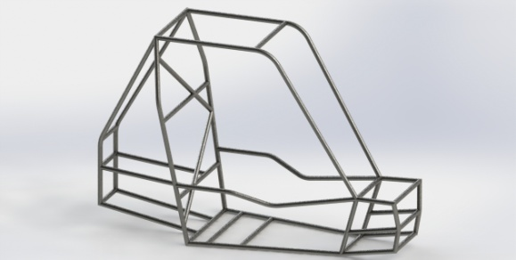

Figure 1 Initial chassis design

|  |  |
| --- | --- |
| **Component** | **Weight (kg)** |
| Tires | 22.5 |
| Suspension | 22.5 |
| Steering | 6.8 |
| Engine | 27 |
| Transmission | 27 |
| Rear Housing | 18 |
| Body Panels | 4.5 |
| Skid Plate | 4.5 |
| Electronics | 2 |
| Brakes | 9 |
| Total | 145 |

III.Material Composition and Properties:

The material used for the members is alloy steel and obeys the specification of Baja SAE.

The name of the material is AISI 4130 steel, 1in round pipes are used for the chassis.

The properties of the steel are as follows:

|  |  |
| --- | --- |
| **Property** | **value** |
| Hardness,Brinel | 197 |
| Hardness,Rockwell | 92 |
| Tensile Strength,Yield | 460 MPa |
| Tensile Strength,Ultimate | 670 MPa |
| Elongation at break | 25.5% |
| Reduction in area | 59.5% |
| Modulus of Elasticity | 205 GPa |
| Bulk Modulus | 160 GPa |
| Poissons Ratio | 0.29 |
| Shear Modulus | 80 GPa |

The composition of the alloy steel is as follows:

|  |  |
| --- | --- |
| Element | Percentage |
| Carbon, C | 0.28-0.33 % |
| Chromium, Cr | 0.80-1.1 % |
| Iron, Fe | 97.03-98.22 % |
| Manganese, Mn | 0.40-0.60 % |
| Molybdenum, Mo | 0.15-0.25 % |
| Phosphorous, P | ≤0.035 % |
| Silicon, Si | 0.15 0.30 % |
| Sulfur, S | ≤0.040 % |

Each impact test is a worst case scenario that could potentially occur at the competition.

There are four tests:

* Front impact test,
* Side impact test,
* Roll over test.
* Rear impact test,

FRONT IMPACT TEST:

Frontal impact is a dynamic event but it is easier to do preliminary analysis using linear elastic quasi-static analysis. Therefore we need to determine a force value to use in the static analysis that is roughly equivalent to the peak dynamic force or average dynamic force observed during an impact

[5] Florida Institute of technology SAE Baja team analyzed the data from ‘The motor Insurance Repair Research Center’ and estimated the maximum g-force that the Baja car will see is 7.9 G’s. To calculate the forces used to analyze the 7.9 G impact, Newton’s second law was used. The force calculation was shown below in equation.

F = m x a

F = 180 x 7.9 x 9.81

=13949.82N

The time was impact was found to be 65milli seconds. This forces were used for analysis by rounding it to 14000N. The boundary conditions and deformations are shown in the figure:

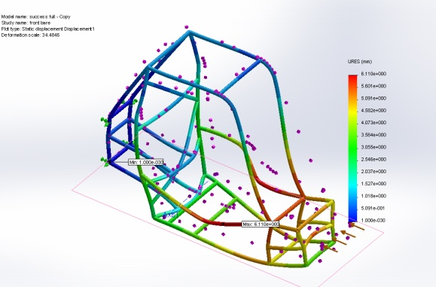

Figure 2 frontal impact deformation

The stresses were found to be 446,728,032 Pa which is less than yield strength. Therefore the factor of safety(FOS) is 1.029. Therefore there is no need of adding additional members and the FOS can increase with adding of members which aid for the stress reduction due to frontal impact.

SIDE IMPACT TEST:

The next step in the analysis was to analyze a side impact with a 4.5 G load. This is equivalent to a loading force of 8000N.

F=m x a

F=180 x4.5 x9.81

F=7946N

This forces were used for analysis by rounding it to 8000N. The deformations were found to be maximum of 15.39mm and minimum of 0mm.

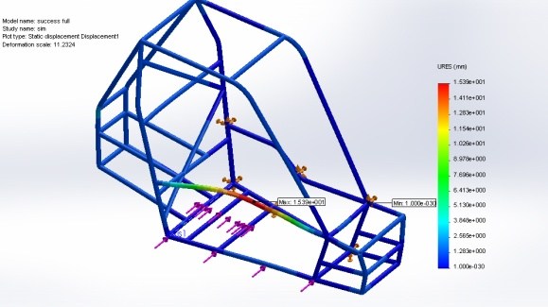

Figure 3 Side Impact Deformation

The stress vary from the range maximum of 599,943,808Pa which is more than yield strength and leads to the failure of the chassis. Thus an additional member has to be added to increase the strength of the chassis.

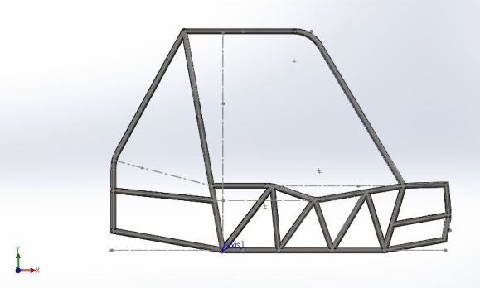

Figure 4 chassis with new members

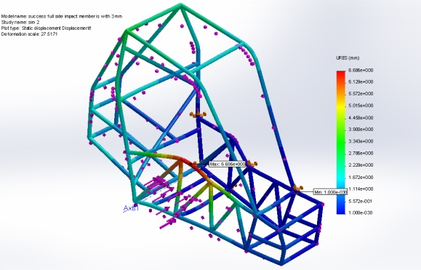

Figure 5 Impact test after addition of new members

ROLL OVER TEST:

This test scenario occurs when the vehicle passes over a ramp with max speed and jumps into air by landing on its RHO. The force used for the roll over analysis is dependent on the height of the drop. The purpose of the roll over analysis is simply to rate the frame for a certain drop height. The starting point will be a ten for drop. For a ten foot drop the impact velocity is calculated to be 25.4 ft/s and impact acceleration and pulse is interpolated as 6g’s and 70 miliseconds respectively [FIU].

F=m x a

F=180 x 9.81 x 6

F=10600N

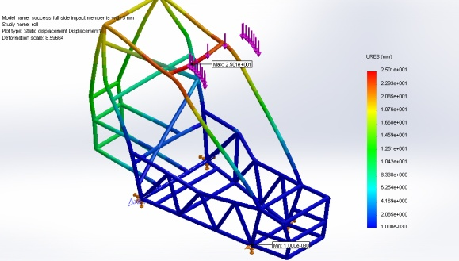

Figure 6 Roll Over Test Deformation

The ideal method of support would be the addition of a support from the SIM to this bend and adding a gusset member between RRH and RHO. The gusset is joined at a distance of 5 in from point of joining of RRH and RHO, which results a chassis a shown in the figure.

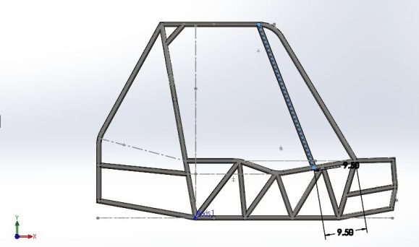

Figure 7 chassis with addition of new members

The chassis is again acted upon by similar forces with similar boundary conditions. The force acted was 11000N and chassis was fixed at the ends of LFS. Thus the results were found to be as shown in the figure.

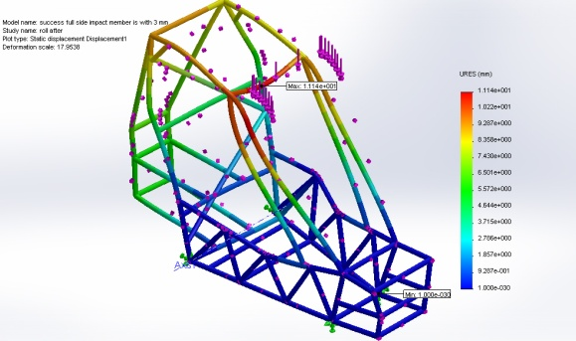

Figure Roll Over Test with additional members

REAR IMPACT TEST:

This scenario occurs when a vehicle hits another vehicle from rear while maneuvering a turn or while passing an obstacle. The forces acted upon the chassis in this test are taken to be equal to the forces acting in ROLL OVER test. This force is acted upon the bends of the Rear Bracing Member. A force of magnitude 10000N is applied each bend sharing half of it and the Front of the chassis fixed at the four corners which constrain the deformation in that direction. The deformation was found to be maximum at the bends itself with a value of 11.59mm.

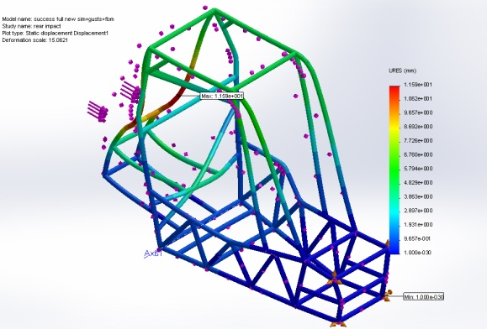

Figure 9 Rear Impact Test

The stresses were maximum at the joint where the engine mounts and the Rear Bracing Members meet. Their values were found to be 83,82,95,936 Pa as maximum and 0 Pa as minimum. This stress induced is much higher than the yield strength of the material. If the force can be transmitted to chassis with even more members the stress concentration can get reduced. Thus two members were added joining the bends and the RRH as shown in the figure.

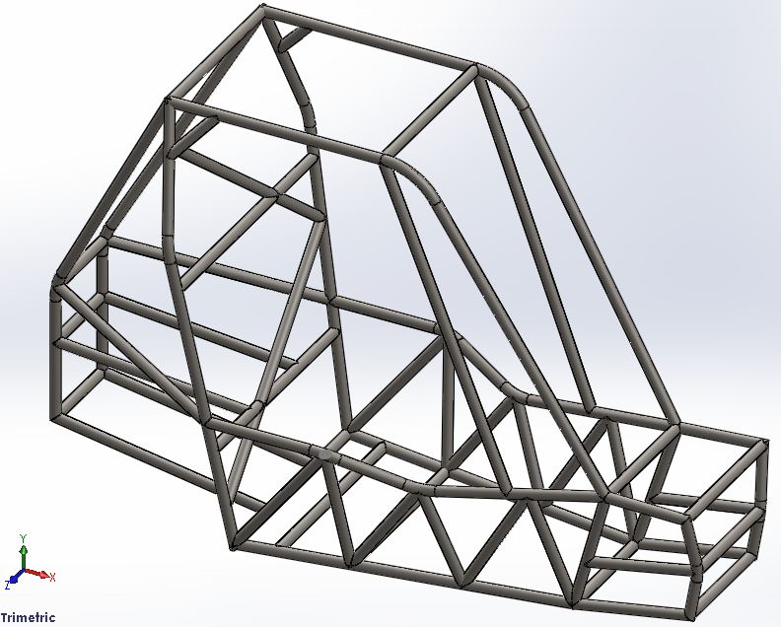

Figure 10 Chassis with New members added

The chassis is subjected to same forces and boundary conditions. The maximum deformation was reduced to a value of 3.44mm and was found to be on the FBM.

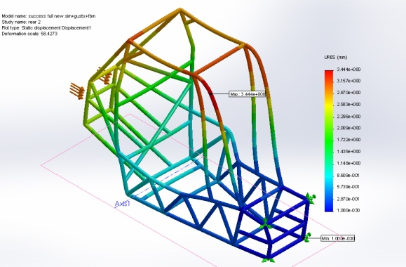

Figure 11 Rear Impact Test with New Members

The maximum stress concentration was found at the point where the FBM and LC meet and its value is 11,67,59,264 Pa and was minimum at the fixed point.

Result:

The finally obtained chassis is more stronger and resistant to failure with optimal increase in weight.

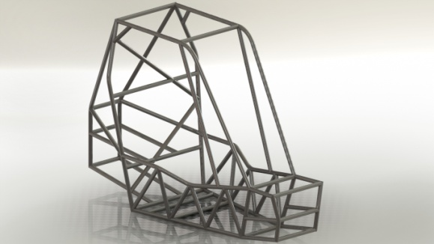

Figure 12 Final Chassis Design

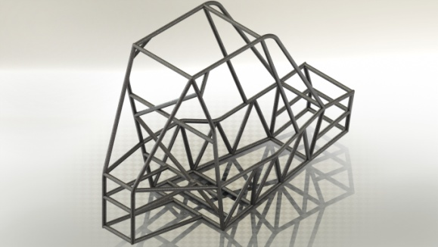

Figure 13 Final chassis design

IV. Conclusions

This paper explores the ways of designing the roll cage of an all terrain vehicle and also sheds on possible key points kept in mind for designing. You can also find analysis results in this paper along with their respective results and formulae used. During the static analysis of the roll cage the design of the roll cage was changed several times in order to obtain a higher FOS. A higher value of factor of safety insures the durability of the roll cage in the most extreme conditions and hence makes the roll cage safe in terms of production.

V. Referances:

**[1]** Aru, S., Jadhav, P., Jadhav, V., Kumar, A. and Angane, P. ‘DESIGN, ANALYSIS AND OPTIMIZATION OF A MULTI- TUBULAR SPACE FRAME’, *International Journal* *of Mechanical and Production Engineering Research and* *Development (IJMPERD)* ISSN(P): 2249-6890; ISSN(E): 2249-8001 Vol. 4, Issue 4, Aug 2014, 37-48© TJPRC Pvt. Ltd

[2] Noorbhasha, N. "Computational analysis for improved design of an SAE BAJA frame structure" .*UNLV Theses,* *Dissertations, Professional Papers, and Capstones*. Paper 736, 12-2010.

[3] Raina, D., Gupta, R. D. and Phanden, R.K. ‘Design and Development for Roll Cage of All- Terrain Vehicle’, *International Journal for Technological Research in* *Engineering (IJTRE)* Volume 2, Issue 7, March-2015 ISSN: 2347-4718

[4] Bharat Kumar Sati, Prashi Upreti, Anirudh Tripathi & Shankar Batra-“ Static and Dynamic Analysis of the Roll Cage for an All-Terrain Vehicle”, Imperial Journal of Interdisciplinary Research (IJIR) Vol-2, Issue-6, and 2016 ISSN: 2454-1362

[5] Paper by Department of Mechanical and Materials Engineering Florida International University, Miami, FL